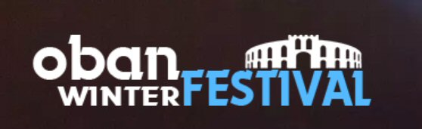
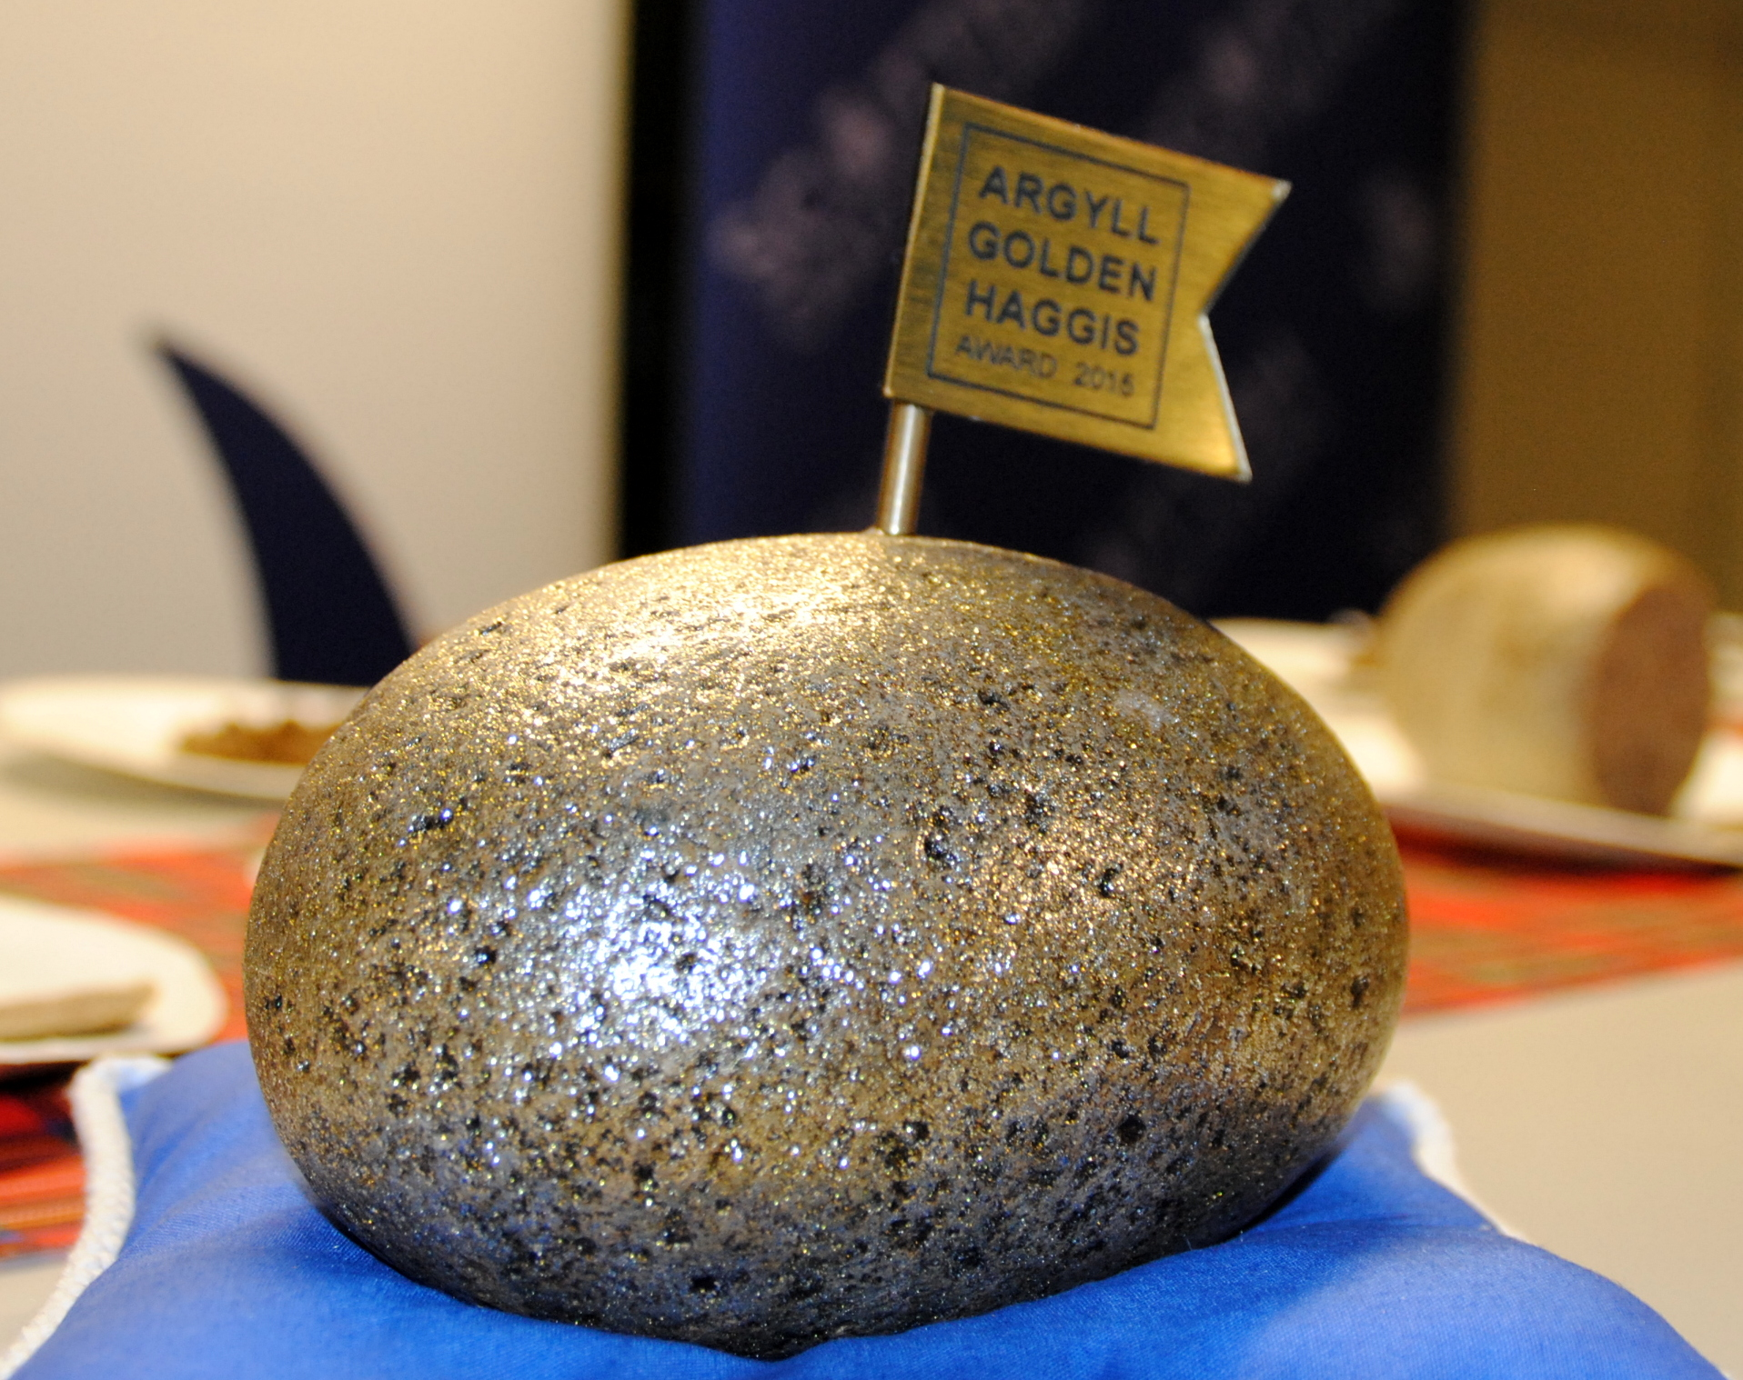
AN ANNUAL CHALLENGE FOR HAGGIS MAKERS EVERYWHERE:-
Oban Winter Festival celebrates St Andrew’s Day with the
GOLDEN HAGGIS AWARD 2023

A COMPETITION TO FIND HAGGIS OF DISTINCTION
To be held on Sunday 26th November 2023
at the Oban Distillery.

CONDITIONS OF ENTRY

- Entries will be limited to one per business.
- Each entry must be made on premises inspected by their Local Authority EHO, Food Standards Scotland or the Food Standards Agency.
- Each entry must consist of one ball haggis of 500g minimum weight.
- Entries may be in either natural or synthetic casings and the judges will be asked to concentrate on what’s inside the casing.
- Entries, successful or otherwise, will not be returned.
- The entries will be judged by a panel of judges.
- A winner will be announced at the prize giving at 3.30pm on Sunday 26th November.
- The judges' decision will be final and no correspondence can be entered into after the event.
- An entry fee of £15.00 per entry should be submitted to the Oban Winter Festival along with a completed entry form by Friday 10th November 2023.
- No late entries will be accepted.
- All products must be submitted by 11.30am on Sunday 26th November 2023 to the competition desk at the Oban Distillery.
- Titles used in promotion must include the year of award

The Golden Haggis Award will be judged alongside “The People’s Choice’ Award

More information at www.obanwinterfestival.com

If you are not coming to Oban, you must send your entry to arrive by 4.00pm on
Saturday 25th November to Jackson Butchers, 2 George Street, Oban PA34 5RX
[Tel: 01631 562016]
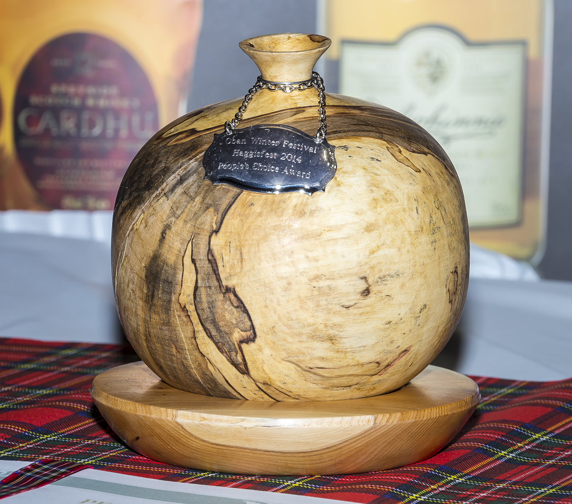
Oban Winter Festival celebrates St Andrew’s Day with the
THE PEOPLE’S CHOICE AWARD 2023

A COMPETITION FOR THE PUBLIC TO DECIDE WHO WINS.
To be held on Sunday 26th November 2023,
at the Oban Distillery.

CONDITIONS OF ENTRY

- Entries will be limited to one per business.
- Each entry must be made on premises inspected by their Local Authority EHO, Food Standards Scotland or the Food Standards Agency.
- The entries will be judged and voted for by the public, one vote per person.
- The winner gaining the most votes will be announced at the prize giving at 3.30pm on Sunday 26th November.
- No correspondence can be entered into after the event.
- An entry fee of £15.00 per entry should be submitted to the Oban Winter Festival along with a completed entry form by Friday 10th November 2023.
No late entries will be accepted.
- Two sticks of haggis, or equivalent (minimum 2.5Kg), must be submitted by 11.30am on Sunday 26th November 2023 at the Oban Distillery.
- The organising committee in Oban will heat and maintain the temperature of the haggis by means of microwave and slow cooker.
- Entrants can display their business name to the public as they sample. A list of entrants with business name, address and contact details will be displayed to assist samplers to source future purchases.
- Voting closes at 3.00pm.
- Titles used in promotion must include the year of award.
- Only People’s Choice Award entrants will be allowed to sell haggis at the event.

The Golden Haggis Award will be judged alongside “The People’s Choice’ Award

More information at www.obanwinterfestival.com

If you are not coming to Oban, you must send your entry to arrive by 4.00pm on
Saturday 25th November to Jackson Butchers, 2 George Street, Oban PA34 5RX
[Tel: 01631 562016]
GOLDEN HAGGIS AWARD 2023
THE PEOPLE’S CHOICE AWARD 2023
Sunday 26th November 2023 at the Oban Distillery.

COMPETITION ENTRY FORM ENTRIES CLOSE 10th NOVEMBER 2023

TO: Pamela Lockhart, Innishail, Croft Road, Oban PA34 5JN
COMPETITION | TO ENTER  Please tick | COST
GOLDEN HAGGIS  one entry @ £15 |  | £
PEOPLE’S CHOICE HAGGIS  one entry @ £15 |  | £
 | TOTAL: | £

(Cheques should be made payable to Oban Winter Festival).

NAME
BUSINESS
ADDRESS
POSTCODE

BUSINESS TELEPHONE

I accept the conditions of the Competitions and undertake to present
my entry/entries at the Oban Distillery at the stipulated times on
Sunday 26th November 2023.

SIGNED:

