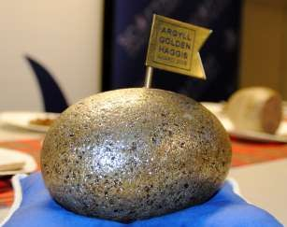

**AN ANNUAL CHALLENGE FOR HAGGIS MAKERS EVERYWHERE:-**

**Oban Winter Festival celebrates St Andrew’s Day with the**

# THE GOLDEN HAGGIS AWARD 2025

A COMPETITION TO FIND HAGGIS OF DISTINCTION

## To be held on Sunday 30th November 2025

at the Oban Distillery. **ENTRIES CLOSE 15th NOVEMBER 2025**

CONDITIONS OF ENTRY

1. Entries will be limited to one per business.
2. Each entry must be made on premises inspected by their Local Authority EHO, Food Standards Scotland or the Food Standards Agency.
3. Each entry must consist of **one ball haggis of 500g minimum weight**.
4. Entries may be in either natural or synthetic casings and the judges will be asked to concentrate on what’s inside the casing.
5. Entries, successful or otherwise, will not be returned.
6. The entries will be judged by a panel of judges.
7. A winner will be announced at the prize giving at 3.00pm on Sunday 30th November.
8. The judges' decision will be final and no correspondence can be entered into after the event.
9. An entry fee of £15.00 per entry should be submitted to the Oban Winter Festival along with a completed entry form by Friday 15th November 2025.
10. No late entries will be accepted.
11. All products must be submitted by 11.30am on Sunday 30th November 2025 to the competition desk at the Oban Distillery.
12. Titles used in promotion must include the year of award

The Golden Haggis Award will be judged alongside “The People’s Choice’ Award More information at [www.obanwinterfestival.com](http://www.obanwinterfestival.com/)

If you are not coming to Oban, you must send your entry to arrive by 4.00pm on Saturday 29th November to Jackson Butchers, 2 George Street, Oban PA34 5RX [Tel: 01631 562016]

**Oban Winter Festival celebrates St Andrew’s Day with the**

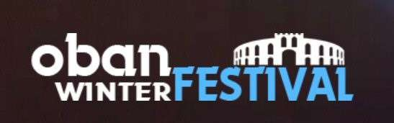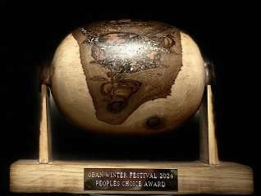

# THE PEOPLE’S CHOICE AWARD 2025

A COMPETITION FOR THE PUBLIC TO DECIDE WHO WINS.

## To be held on Sunday 30th November 2025,

at the Oban Distillery. **ENTRIES CLOSE 15th NOVEMBER 2025**

CONDITIONS OF ENTRY

1. Entries will be limited to one per business.

**NEW** - A maximum of 20 entrants will be accepted on a first come first included basis.

1. Each entry must be made on premises inspected by their Local Authority EHO, Food Standards Scotland or the Food Standards Agency.
2. The entries will be judged and voted for by the public.
3. The winner gaining the most votes will be announced at the prize giving at 3.00pm on Sunday 30th November.
4. No correspondence can be entered into after the event.
5. An entry fee of £15.00 per entry should be submitted to the Oban Winter Festival along with a completed entry form by Friday 15th November 2025.

No late entries will be accepted.

1. **Two sticks of haggis, or equivalent (minimum 2.5Kg),** must be submitted by 11.30am on Sunday 30th November 2025 at the Oban Distillery.
2. The organising committee in Oban will heat and maintain the temperature of the haggis by means of microwave and bain mairie.
3. A list of entrants with business name, address and contact details will be displayed to assist samplers to source future purchases.
4. Voting closes at 2.45pm.
5. Titles used in promotion must include the year of award.
6. Only People’s Choice Award entrants will be allowed to sell haggis at the event. The Golden Haggis Award will be judged alongside “The People’s Choice’ Award

More information at [www.obanwinterfestival.com](http://www.obanwinterfestival.com/)

If you are not coming to Oban, you must send your entry to arrive by 4.00pm on Saturday 29th November to Jackson Butchers, 2 George Street, Oban PA34 5RX [Tel: 01631 562016]

 

**THE GOLDEN HAGGIS AWARD 2025 THE PEOPLE’S CHOICE AWARD 2025**

## Sunday 30th November 2025 at the Oban Distillery.

COMPETITION ENTRY FORM **ENTRIES CLOSE 15th NOVEMBER 2025**

RETURN TO: Pamela Lockhart, Innishail, Croft Road, Oban PA34 5JN

|  |  |  |
| --- | --- | --- |
| COMPETITION | TO ENTER  Please tick | COST |
| **THE GOLDEN HAGGIS**  **one entry @ £15** |  | £ |
| **THE PEOPLE’S CHOICE HAGGIS**  **one entry @ £15** |  | £ |
|  | TOTAL: | £ |

(Cheques should be made payable to Oban Winter Festival).

|  |  |  |
| --- | --- | --- |
| NAME |  | |
| BUSINESS |  | |
| ADDRESS |  | |
|  | |
|  | |
| POSTCODE |  |  |
| BUSINESS TELEPHONE |  |  |

I accept the conditions of the Competitions and undertake to present my entry/entries at the Oban Distillery at the stipulated times on Sunday 30th November 2025.

SIGNED: