
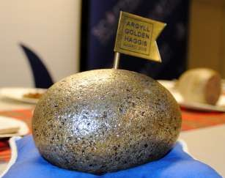

AN ANNUAL CHALLENGE FOR HAGGIS MAKERS EVERYWHERE:-
Oban Winter Festival celebrates St Andrew’s Day with the

THE GOLDEN HAGGIS AWARD 2026
A COMPETITION TO FIND HAGGIS OF DISTINCTION

To be held on Sunday 29th November 2026
at the Argyllshire Gathering, Breadalbane Street, Oban.
ENTRIES CLOSE 6th NOVEMBER 2026
CONDITIONS OF ENTRY
- Entries will be limited to one per business.
- Each entry must be made on premises inspected by their Local Authority EHO, Food Standards Scotland or the Food Standards Agency.
- Each entry must consist of one ball haggis of 500g minimum weight.
- Entries may be in either natural or synthetic casings and the judges will be asked to concentrate on what’s inside the casing.
- Entries, successful or otherwise, will not be returned.
- The entries will be judged by a panel of judges.
- A winner will be announced at the prize giving at 3.00pm on Sunday 29th November.
- The judges' decision will be final and no correspondence can be entered into after the event.
- An entry fee of £15.00 per entry should be submitted to the Oban Winter Festival along with a completed entry form by Friday 6th November 2026.
- No late entries will be accepted.
- All products must be submitted by 11.30am on Sunday 29th November 2026 to the competition desk at the Argyllshire Gathering.
- Titles used in promotion must include the year of award

The Golden Haggis Award will be judged alongside “The People’s Choice’ Award More information at www.obanwinterfestival.com
If you are not coming to Oban, you must send your entry to arrive by 4.00pm on Saturday 28th November to Jackson Butchers, 2 George Street, Oban PA34 5RX [Tel: 01631 562016]

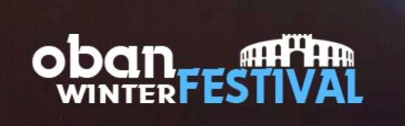

Oban Winter Festival celebrates St Andrew’s Day with the

THE PEOPLE’S CHOICE AWARD 2026
A COMPETITION FOR THE PUBLIC TO DECIDE WHO WINS.

To be held on Sunday 29th November 2026,
at the Argyllshire Gathering, Breadalbane Street, Oban.
ENTRIES CLOSE 6th NOVEMBER 2026
CONDITIONS OF ENTRY
- Entries will be limited to one per business. A maximum of 20 entrants will be accepted on a first come first included basis.
- Each entry must be made on premises inspected by their Local Authority EHO, Food Standards Scotland or the Food Standards Agency.
- The entries will be judged and voted for by the public.
- The winner gaining the most votes will be announced at the prize giving at 3.00pm on Sunday 29th November.
- No correspondence can be entered into after the event.
- An entry fee of £15.00 per entry should be submitted to the Oban Winter Festival along with a completed entry form by Friday 6th November 2026.
No late entries will be accepted.
- Two sticks of haggis, or equivalent (minimum 2.5Kg), must be submitted by 11.30am on Sunday 29th November 2026 at the Argyllshire Gathering, Breadalbane St, Oban.
- The organising committee in Oban will heat and maintain the temperature of the haggis by means of microwave and bain mairie.
- A list of entrants with business name, address and contact details will be displayed to assist samplers to source future purchases.
- Voting closes at 2.45pm.
- Titles used in promotion must include the year of award.
The Golden Haggis Award will be judged alongside “The People’s Choice’ Award
More information at www.obanwinterfestival.com

If you are not coming to Oban, you must send your entry to arrive by 4.00pm on Saturday 28th November to Jackson Butchers, 2 George Street, Oban PA34 5RX [Tel: 01631 562016]

THE GOLDEN HAGGIS AWARD 2026 THE PEOPLE’S CHOICE AWARD 2026

Sunday 29th November 2026 at the Argyllshire Gathering.
COMPETITION ENTRY FORM ENTRIES CLOSE 6th NOVEMBER 2026
By POST: RETURN TO: Pamela Lockhart, Innishail, Croft Road, Oban PA34 5JN
By EMAIL: Complete this page & send to marketing@obanwinterfestival.com

COMPETITION | TO ENTER  Please tick | COST
THE GOLDEN HAGGIS  one entry @ £15 |  | £
THE PEOPLE’S CHOICE HAGGIS  one entry @ £15 |  | £
 | TOTAL: | £
By Post: Cheques should be made payable to Oban Winter Festival
Online: Account name: Oban Winter Festival Sort Code: 80 22 60 Account Number: 10257967

NAME
BUSINESS
ADDRESS
POSTCODE
BUSINESS TELEPHONE

I accept the conditions of the Competitions and undertake to present my entry/entries at the Oban Distillery at the stipulated times on Sunday 29th November 2026.
SIGNED:

